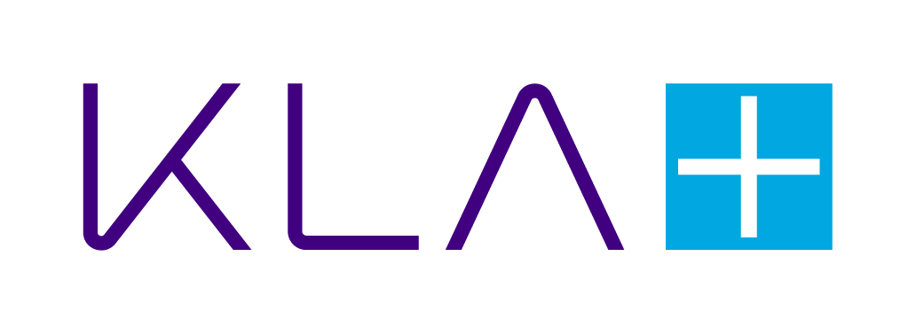

Sign In

**KLA Careers**

**Search for Jobs**

**Introduce Yourself**

**Manufacturing Design Engineer - (Thin Film Deposition/Vacuum Deposition)**

USA-CA-Baldwin Park-ROMA

Full time

Posted 15 Days Ago

2530188

[**Appl**](https://kla.wd1.myworkdayjobs.com/en-US/Search/job/Manufacturing-Design-Engineer_2530188/apply)

[**y**](https://kla.wd1.myworkdayjobs.com/en-US/Search/job/Manufacturing-Design-Engineer_2530188/apply)

# Company Overview

KLA is a global leader in diversified electronics for the semiconductor manufacturing ecosystem. Virtually every electronic device in the world is produced using our technologies. No laptop, smartphone, wearable device, voice-controlled gadget, flexible screen, VR device or smart car would have made it into your hands without us. KLA invents systems and solutions for the manufacturing of wafers and reticles, integrated circuits, packaging, printed circuit boards and flat panel displays. The innovative ideas and devices that are advancing humanity all begin with inspiration, research and development. KLA focuses more than average on innovation and we invest 15% of sales back into R&D. Our expert teams of physicists, engineers, data scientists and problem-solvers work together with the world’s leading technology providers to accelerate the delivery of tomorrow’s electronic devices. Life here is exciting and our teams thrive on tackling really hard problems. There is never a dull moment with us.

# Group/Division

The SensArray division is the world leading provider of in situ processing measurement and control solutions for the semiconductor industry. The company provides measurement and control solutions to both semiconductor fabs and mask shops to ensure that yields are consistently high thus enabling cost-effective manufacturing SensArray business unit is dedicate to support customer R&D phase as well as HVM with in-situ thermal process control. SensArray business unit enable APC (Automated Process Control) to improve process optimization and yield improvement.

# Job Description/Preferred Qualifications

Are you a hands-on problem solver who thrives in a fast-paced, high-tech environment? Do you enjoy transforming complex challenges into streamlined, effective solutions? If so, we’d love to have you on our team!

We’re seeking a Manufacturing Design Engineer to help drive innovation and operational excellence in our cutting-edge semiconductor production line. This is your opportunity to work with groundbreaking technology, collaborate with top-tier talent, and make a meaningful impact every day.

# What You’ll Do

Set up, troubleshoot, and upgrade thin film/vacuum deposition equipment and MEMS or Display packaging systems

Ensure smooth and efficient operation of the production line

Resolve real-time manufacturing issues with speed and precision

Lead continuous improvement initiatives that enhance performance and productivity

Support the rollout and integration of new equipment and upgrades

Collaborate cross-functionally to boost quality and throughput

Conduct root cause analysis and implement effective corrective actions

Develop clear documentation and training materials

Manage process changes and coordinate with suppliers

# What You’ll Bring

Bachelor’s degree in a STEM field with 3+ years of relevant experience

Strong mechanical and electrical aptitude

Excellent communication skills and a commitment to safety

Proficiency in reading and creating CAD drawings

Experience with system integration

Bonus: Familiarity with high vacuum systems, 8D problem-solving methodology, or semiconductor manufacturing Why Join KLA?

Work with innovative technologies in a rapidly growing industry

Be part of a collaborative, forward-thinking team

Access opportunities for professional growth, learning, and leadership

Make a tangible impact on products that shape the future

# Minimum Qualifications

Bachelors Degree and minimum of 5 years related experience, Master's Degree and 3 years minimum related experience.

Base Pay Range: $94,800.00 - $161,200.00 Annually

Primary Location: USA-CA-Baldwin Park-ROMA

KLA’s total rewards package for employees may also include participation in performance incentive programs and eligibility for additional benefits including but not limited to: medical, dental, vision, life, and other voluntary benefits, 401(K) including company matching, employee stock purchase program (ESPP), student debt assistance, tuition reimbursement program, development and career growth opportunities and programs, financial planning benefits, wellness benefits including an employee assistance program (EAP), paid time off and paid company holidays, and family care and bonding leave.

Interns are eligible for some of the benefits listed. Our pay ranges are determined by role, level, and location. The range displayed reflects the pay for this position in the primary location identified in this posting. Actual pay depends on several factors, including state minimum pay wage rates, location, job-related skills, experience, and relevant education level or training. We are committed to complying with all applicable federal and state minimum wage requirements where applicable. If applicable, your recruiter can share more about the specific pay range for your preferred location during the hiring process.

KLA is proud to be an Equal Opportunity Employer. We will ensure that qualified individuals with disabilities are provided reasonable accommodation to participate in the job application or interview process, to perform essential job functions, and to receive other benefits and privileges of employment. Please contact us at talent.acquisition@kla.com or at +1-408-352-2808 to request accommodation.

Be aware of potentially fraudulent job postings or suspicious recruiting activity by persons that are currently posing as KLA employees. KLA never asks for any financial compensation to be considered for an interview, to become an employee, or for equipment. Further, KLA does not work with any recruiters or third parties who charge such fees either directly or on behalf of KLA. Please ensure that you have searched

[KLA’s Careers website](https://kla.com/careers) for legitimate job postings. KLA follows a recruiting process that involves multiple interviews in person or on video conferencing with our hiring managers. If you are concerned that a communication, an interview, an offer of employment, or that an employee is not legitimate, please send an email to talent.acquisition@kla.com to confirm the person you are communicating with is an employee. We take your privacy very seriously and confidentially handle your information.

About Us



Now hiring curious minds who want to learn even more. Explore KLA at [www.kla.com/careers](https://www.kla.com/careers)

KLA is proud to be an Equal Opportunity Employer.

We will ensure that qualified individuals with disabilities are provided reasonable accommodation to participate

**Read More**

Follow Us

[Privacy Policy](https://www.kla-tencor.com/privacy-policy)



© 2025 Workday, Inc. All rights reserved.